 | 26.9.8 Editors - Properties Editor - Modifiers Properties Tab - Grease Pencil - Generate Modifiers
Table of content
Detailed table of content 1
Grease Pencil - Generate modifiers 9
Array 9
Build 11
Dot Dash 17
Envelope 19
Length 21
Line Art 23
Mirror 30
Multiple Strokes 31
Outline 33
Simplify 35
Subdivide 36

Detailed table of content

Detailed table of content
Detailed table of content 1
Grease Pencil - Generate modifiers 9
Array 9
Count 9
Material Override 9
Relative Offset subpanel 9
Factor X/Y/Z 9
Constant Offset subpanel 10
Distance X/Y/Z 10
Object Offset subpanel 10
Object 10
Randomize 10
Offset 10
Rotation 10
Scale 10
Uniform Scale 10
Seed 10
Influence subpanel 10
Layer 10
Invert 10
Layer Pass 11
Use Layer pass 11
Layer pass value 11
Invert 11
Material 11
Invert 11
Material Pass 11
Use Material pass 11
Material pass value 11
Invert 11
Build 11
Mode 11
Sequential mode 12
Transition 12
Timing 12
Natural Drawing Speed 12
Speed Factor 12
Maximum Gap 12
Number of Frames 12
Frames 12
Delay 12
Percentage Factor 12
Factor 12
Object 12
Concurrent Mode 12
Transition 13
Grow 13
Shrink 13
Vanish 13
Timing 13
Number of frames 13
Time Alignment 13
Align Start 13
Align End 13
Frames 13
Delay 13
Percentage Factor 13
Time Alignment 13
Align Start 14
Align End 14
Factor 14
Object 14
Additive 14
Timing 14
Natural Drawing Speed 14
Speed Factor 14
Maximum Gap 14
Number of frames 14
Time Alignment 14
Align Start 14
Align End 14
Frames 14
Delay 15
Percentage Factor 15
Time Alignment 15
Align Start 15
Align End 15
Factor 15
Start delay 15
Frames 15
Object 15
Custom Range 15
Start 15
End 15
Fade subpanel 15
Factor 15
Thickness 16
Opacity 16
Weight Output 16
Influence subpanel 16
Layer 16
Invert 16
Layer Pass 16
Use Layer pass 16
Layer pass value 16
Invert 16
Material 16
Invert 16
Material Pass 16
Use Material pass 16
Material pass value 16
Invert 17
Dot Dash 17
Offset 17
Segment list 17
Add Segment 17
Remove Segment 17
Move Dash Segment up or down 17
Search element 17
Edit Box 17
Invert 17
Sort by name 17
Reverse 17
Dash 18
Gap 18
Radius 18
Opacity 18
Material Index 18
Cyclic 18
Influence subpanel 18
Layer 18
Invert 18
Layer Pass 18
Use Layer pass 18
Layer pass value 18
Invert 18
Material 18
Invert 19
Material Pass 19
Use Material pass 19
Material pass value 19
Invert 19
Envelope 19
Mode 19
Deform 19
Segments 19
Fills 19
Spread Length 19
Thickness 19
Strength 19
Material Index 20
Skip Segments 20
Influence subpanel 20
Layer 20
Invert 20
Layer Pass 20
Use Layer pass 20
Layer pass value 20
Invert 20
Material 20
Invert 20
Material Pass 20
Use Material pass 20
Material pass value 20
Invert 21
Vertex Group 21
Inverse Pass 21
Length 21
Mode 21
Factor Start/End 21
Used Length 21
Curvature subpanel 21
Point Density 21
Segment Influence 21
Filter Angle 21
Invert 21
Random Offset subpanel 22
Random offset Start 22
Random offset End 22
Random Noise Offset 22
Seed 22
Randomize subpanel 22
Step 22
Influence 22
Layer 22
Invert 22
Layer Pass 22
Use Layer pass 22
Layer pass value 22
Invert 22
Material 23
Invert 23
Material Pass 23
Use Material pass 23
Material pass value 23
Invert 23
Line Art 23
Source Type 24
Collection 24
Collection 24
Invert 24
Layer 24
Material 24
Line Thickness 24
Opacity 24
Object 24
Object 24
Layer 24
Material 24
Line Thickness 24
Opacity 24
Scene 25
Layer 25
Material 25
Line Thickness 25
Opacity 25
Edge types subpanel 25
Create 25
Use Contour 25
Silhouette Filtering 25
Use Crease 25
Crease Threshold 25
Crease 25
Material Borders 25
Intersections 26
Edge Marks 26
Loose 26
Light Object 26
Light Contour 26
Cast Shadow 26
Illumination filtering 26
Options 26
Allow Overlaping Types 26
Light Reference subpanel 26
Light Object 26
Shadow Camera Size 26
Near 26
Far 26
Geometry Processing subpanel 27
Custom Camera 27
Overlapping Edges as Contour 27
Instanced Objects 27
Clipping Boundaries 27
Crease on Smooth 27
Crease on Sharp 27
Force Back Face Culling 27
Occlusion Subpanel 27
Range 27
Material Mask subpanel 27
Masks 28
Exact match 28
Intersection subpanel 28
Collection Masks 28
Exact match 28
Face Mask Filtering subpanel 28
Invert 28
Boundaries 28
Keep Contour 28
Chain 28
Intersection with Contour 28
All Lines 28
Loose Edges 28
Loose As Contour 29
Preserve Details 29
Geometry Space 29
Image Threshold 29
Smooth tolerance 29
Angle Splitting 29
Vertex Weight Transfer subpanel 29
Filter Source 29
Invert Vertex Group 29
Match Output 29
Target 29
Composition 29
Overscan 29
Image boundary trimming 29
Depth Offset 30
Towards custom camera 30
Bake subpanel 30
Bake Line Art / Bake Line Art (All) 30
Clear Baked Line Art / Clear Baked Line Art ( All) 30
Mirror 30
Object 30
Influence 30
Layer 30
Invert 30
Layer Pass 30
Use Layer pass 31
Layer pass value 31
Invert 31
Material 31
Invert 31
Material Pass 31
Use Material pass 31
Material pass value 31
Invert 31
Multiple Strokes 31
Duplicates 31
Distance 31
Offset 31
Fade 32
Center 32
Thickness 32
Opacity 32
Influence subpanel 32
Layer 32
Invert 32
Layer Pass 32
Use Layer pass 32
Layer pass value 32
Invert 32
Material 32
Invert 32
Material Pass 32
Use Material pass 33
Material pass value 33
Invert 33
Outline 33
Thickness 33
Keep Shape 34
Subdivisions 34
Sample Length 34
Outline material 34
Target object 34
Influence subpanel 34
Layer 34
Invert 34
Layer Pass 34
Use Layer pass 34
Layer pass value 34
Invert 34
Material 34
Invert 34
Material Pass 35
Use Material pass 35
Material pass value 35
Invert 35
Simplify 35
Mode 35
Fixed 35
Adaptive 35
Sample 35
Merge 35
Iterations 35
Influence subpanel 35
Layer 35
Invert 36
Layer Pass 36
Use Layer pass 36
Layer pass value 36
Invert 36
Material 36
Invert 36
Material Pass 36
Use Material pass 36
Material pass value 36
Invert 36
Subdivide 36
Subdivision Type 37
Catmull-Clark 37
Simple 37
Subdivisions 37
Influence subpanel 37
Layer 37
Invert 37
Layer Pass 37
Use Layer pass 37
Layer pass value 37
Invert 37
Material Pass 37
Use Material pass 37
Material pass value 37
Invert 37
Pass 38
Invert 38

Grease Pencil - Generate modifiers

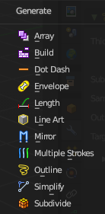
Some of the modifiers are just available for specific object types.
Left grease pencil object, right a mesh object.

Array
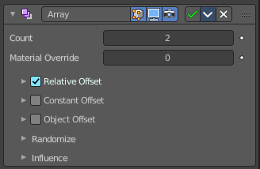
The Array modifier creates an array of copies of the base object. Each copy can offset from the previous one in any of a number of possible ways. Vertices in adjacent copies can be merged if they are nearby, allowing smooth Subdivision Surface frameworks to be generated.
This modifier can be useful when combined with tillable meshes for quickly developing large scenes. It is also useful for creating complex repetitive shapes.
Multiple Array modifiers may be active for an object at the same time. This allows to create complex three-dimensional constructs.
Hint for Offset Calculation. The transformation applied from one copy to the next is calculated as the sum of the three different components (Relative, Constant and Object), each of which can be enabled/disabled independently of the others. This allows, for example, a relative offset of (1.0, 0.0, 0.0) and a constant offset of (0.1, 0.0, 0.0), giving an array of objects neatly spaced along the X axis with a constant 0.1 unit between them, whatever the original object’s size.

Count
Number of Items

Material Override
Index of the material used for generated strokes. A value of 0 uses the original material.

Relative Offset subpanel

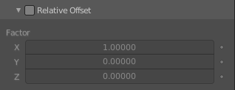
Factor X/Y/Z
Adds a translation equal to the object’s bounding box size along each axis to the offset, multiplied by a scaling factor. X, Y and Z scaling factors can be specified.

Constant Offset subpanel

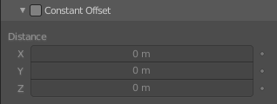
Distance X/Y/Z
Adds a constant translation component to the duplicate object’s offset. X, Y and Z constant components can be specified.

Object Offset subpanel
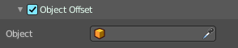
Adds a transformation taken from a chosen object relative to the current object to the offset.

Object
Choose an object.

Randomize
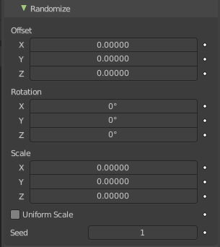
Randomize the transform values.

Offset
Randomize the offset values.

Rotation
Randomize the rotation values.

Scale
Randomize the scale values.

Uniform Scale
Use uniform scaling.

Seed
The random seed value.

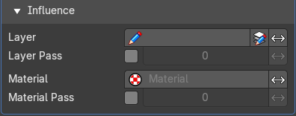
Influence subpanel

Layer
Restricts the effect only to one layer or to any layers that share the same pass index. Click to pick the layer that you want to use.

Invert
Inverts the influence.

Layer Pass
The layer pass index.

Use Layer pass
Use the layer pass.

Layer pass value
The layer pass value.

Invert
Inverts the influence.

Material
Restricts the effect only to material that share the same material or pass index. Click to pick the material that you want to use.

Invert
Inverts the influence.

Material Pass
The material pass index.

Use Material pass
Use the Material pass.

Material pass value
The Material pass value.

Invert
Inverts the influence.

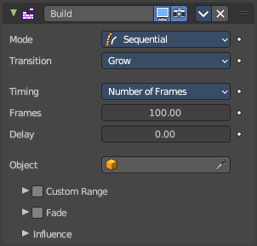
Build
The Build modifier lets the strokes of the grease pencil object appear or disappear over time when you play the animation.

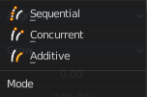
Mode
How many strokes are animated at the same time.

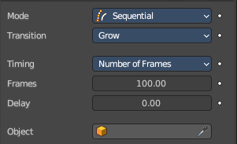
Sequential mode
Strokes appear or disappear one after the other.

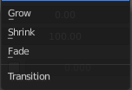
Transition
How the strokes are animated. The items should be self explaining.

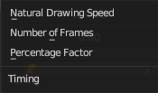
Timing
How to calculate the timing of the frames.

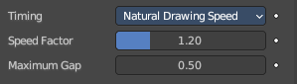
Natural Drawing Speed
Use recorded speed multiplied by a factor.

Speed Factor
Multiply recorded drawing speed by a factor.

Maximum Gap
The maximum gap between strokes in seconds.

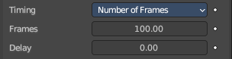
Number of Frames
Set a fixed number of frames for all build animations.

Frames
Maximum number of frames that the build effect can run.

Delay
Number of frames to delay before the modifier has any effect.

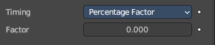
Percentage Factor
Set a manual percentage to build.

Factor
How much the stroke is visible.

Object
Pick an object as the starting position.

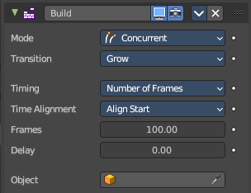
Concurrent Mode
All strokes appear or disappear at once.

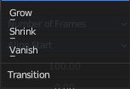
Transition
How the strokes are animated.

Grow
Grow over the animation time.

Shrink
Shrink over the animation time.

Vanish
Vanish over the animation time.

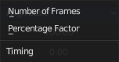
Timing
What method to use to build animations. Number of frames, or percentage.

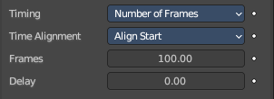
Number of frames

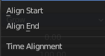
Time Alignment
When strokes should start to appear or disappear.

Align Start
All strokes appears at the same time.

Align End
All strokes disappears at the same time.

Frames
Maximum number of frames that the build effect can run.

Delay
Number of frames after each GP keyframe before the modifier has any effect.

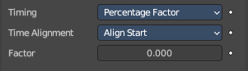
Percentage Factor

Time Alignment
When strokes should start to appear or disappear.

Align Start
All strokes appears at the same time.

Align End
All strokes disappears at the same time.

Factor
How much the stroke is visible.

Object
Pick an object as the starting position.

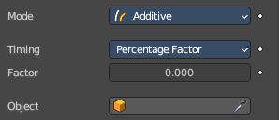
Additive
Builds only new strokes. Assumes additive painting.

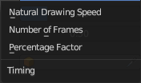
Timing
What method to use to build animations.

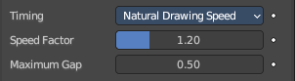
Natural Drawing Speed

Speed Factor
Multiply the recording speed by a factor.

Maximum Gap
The maximum gap between strokes in seconds.

Number of frames

Time Alignment
When strokes should start to appear or disappear.

Align Start
All strokes appears at the same time.

Align End
All strokes disappears at the same time.

Frames
Maximum number of frames that the build effect can run.

Delay
Number of frames after each GP keyframe before the modifier has any effect.

Percentage Factor

Time Alignment
When strokes should start to appear or disappear.

Align Start
All strokes appears at the same time.

Align End
All strokes disappears at the same time.

Factor
How much the stroke is visible.

Start delay
Number of frames after each GP keyframe before the modifier has any effect.

Frames
Maximum number of frames that the build effect can run.

Object
Pick an object as the starting position.

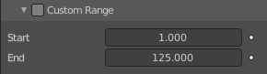
Custom Range
Only modify strokes that lies in the specified time frame.

Start
The first frame of the range.

End
The last frame of the range.

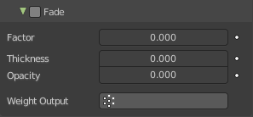
Fade subpanel
Fade out strokes instead of cutting them off.

Factor
The factor for how much the stroke is fading out.

Thickness
How much strength fading applies on top of stroke thickness.

Opacity
How much strength fading applies on top of stroke opacity.

Weight Output
Limit the fade to a vertex group.

Influence subpanel

Layer
Restricts the effect only to one layer or to any layers that share the same pass index. Click to pick the layer that you want to use.

Invert
Inverts the influence.

Layer Pass
The layer pass index.

Use Layer pass
Use the layer pass.

Layer pass value
The layer pass value.

Invert
Inverts the influence.

Material
Restricts the effect only to material that share the same material or pass index. Click to pick the material that you want to use.

Invert
Inverts the influence.

Material Pass
The material pass index.

Use Material pass
Use the Material pass.

Material pass value
The Material pass value.

Invert
Inverts the influence.

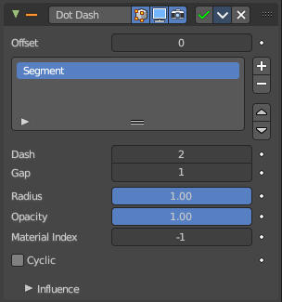
Dot Dash
Turns a grease pencil stroke into a dotted line.

Offset
The offset into each stroke before the dot creation starts.

Segment list
Manage the single segments of the dotted dash. Segments gets repeated as they appear in the list. Means when you just have one segment in the list, then this shape will be repeated. When you have two, then the first will be displayed, then the second, then the first, and so on. Every segment can have its own settings. Which are managed below.

Add Segment
Add a new dash segment.

Remove Segment
Remove the dash segment.

Move Dash Segment up or down
Moves the selected dash segment up or down in the list.

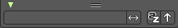
Search element
By clicking at the triangle button you reveal a search field with which you can search through the list.

Edit Box
Type in the search term and hit enter.

Invert
Inverts the search term.

Sort by name
Sorts the list alphabetically.

Reverse
Inverts the list.

Dash
The number of points (vertices) from the orignal stroke to include in this segment.

Gap
The number of points (vertices) skipped after this segment.

Radius
The radius of the segment. Maximum is 1 of the original stroke.

Opacity
The visibility of this segment.

Material Index
What material to use.

Cyclic
Enable cyclic on individual stroke dashes.

Influence subpanel

Layer
Restricts the effect only to one layer or to any layers that share the same pass index. Click to pick the layer that you want to use.

Invert
Inverts the influence.

Layer Pass
The layer pass index.

Use Layer pass
Use the layer pass.

Layer pass value
The layer pass value.

Invert
Inverts the influence.

Material
Restricts the effect only to material that share the same material or pass index. Click to pick the material that you want to use.

Invert
Inverts the influence.

Material Pass
The material pass index.

Use Material pass
Use the Material pass.

Material pass value
The Material pass value.

Invert
Inverts the influence.

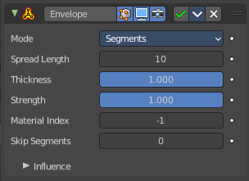
Envelope
Generates a envelope shape that connects all points in this envelope.

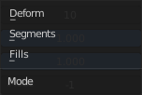
Mode

Deform
Deform the stoke to best match the envelope shape.

Segments
Add segments to create the envelope. Keep the original stroke.

Fills
Add Fill segments to create the envelope. This method does not keep the original stroke.

Spread Length
The number of points to skip to create straight segments.

Thickness
Thickness multiplier for the thickness of the new stroke.

Strength
Strength multiplier for the strength of the new stroke.

Material Index
The material index of the material that is used.

Skip Segments
Define a number of segments to skip to reduce the complexity.

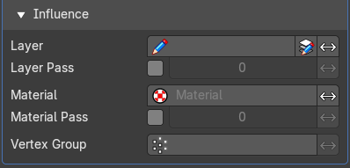
Influence subpanel

Layer
Restricts the effect only to one layer or to any layers that share the same pass index. Click to pick the layer that you want to use.

Invert
Inverts the influence.

Layer Pass
The layer pass index.

Use Layer pass
Use the layer pass.

Layer pass value
The layer pass value.

Invert
Inverts the influence.

Material
Restricts the effect only to material that share the same material or pass index. Click to pick the material that you want to use.

Invert
Inverts the influence.

Material Pass
The material pass index.

Use Material pass
Use the Material pass.

Material pass value
The Material pass value.

Invert
Inverts the influence.

Vertex Group
Assign a vertex group to modulate the deform.

Inverse Pass
Inverts the influence.

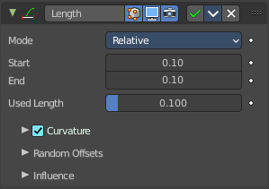
Length
The Length Modifier extends or shortens the original strokes length.

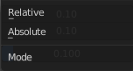
Mode
Defines the mode to use for the length calculation. Relative to the length of the grease pencil stroke, or absolute in geometry space.

Factor Start/End
Length difference for each stroke.

Used Length
What position of the stroke is used for the calculation of the extension.

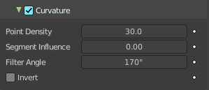
Curvature subpanel
Follow the curvature of the stroke.

Point Density
Multiplied by Start/End for the total added point count.

Segment Influence
How much the length of the individual segments should influence the final computed curvature.

Filter Angle
Ignore points of the stroke that derivate from their neighbours by more than this angle.

Invert
Invert the curvature of the stroke's extension.

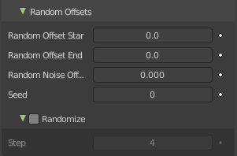
Random Offset subpanel
Randomization for the start / end lengths.

Random offset Start
Size of random length added to the start of each stroke.

Random offset End
Size of random length added to the end of each stroke.

Random Noise Offset
Smoothly offset the random value of each stroke.

Seed
The random seed value.

Randomize subpanel
Use random values over time.

Step
Number of frames before recalculate random values again.

Influence

Layer
Restricts the effect only to one layer or to any layers that share the same pass index. Click to pick the layer that you want to use.

Invert
Inverts the influence.

Layer Pass
The layer pass index.

Use Layer pass
Use the layer pass.

Layer pass value
The layer pass value.

Invert
Inverts the influence.

Material
Restricts the effect only to material that share the same material or pass index. Click to pick the material that you want to use.

Invert
Inverts the influence.

Material Pass
The material pass index.

Use Material pass
Use the Material pass.

Material pass value
The Material pass value.

Invert
Inverts the influence.

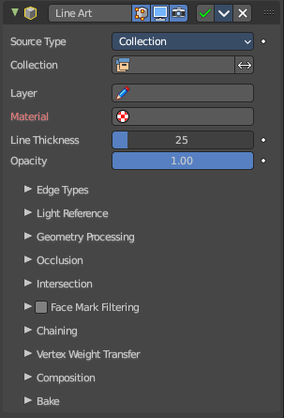
Line Art
The Line Art modifier generates stylized line art from the scene or selected source collection or objects.
Note that due to lack of global cache at the moment, each Line Art modifier will run the entire occlusion calculation for itself. So if you have multiple line art modifiers to select different parts of the scene (to apply different styles, etc.), the evaluation will take much longer. There are plans to remedy this in the future, but this is a known limitation for now.

This modifier requires to have a ACTIVE camera in the scene, since the outline is created from this active camera. And the outline is created from exact this view of the camera. So better switch to camera view to check if the view fits.
The active camera has the active orange triangle above the widget. You can also see the active camera in the Scene properties.
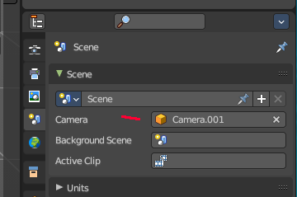
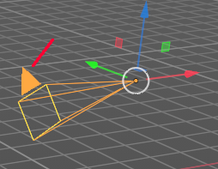

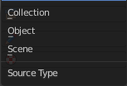
Source Type
What type of geometry source should line art be generated from.

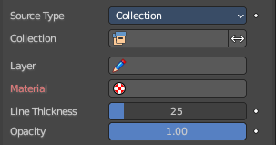
Collection

Collection
The collection where you want to apply the line art to.

Invert
Inverts the selection of collections.

Layer
Grease Pencil layer that is assigned to the generated strokes.

Material
Grease pencil material assigned to the generated strokes.

Line Thickness
The thickness of the line.

Opacity
The opacity of the line.

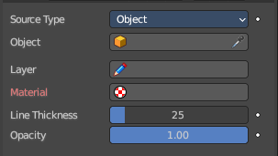
Object

Object
The object where you want to apply the line art to.

Layer
Grease Pencil layer that is assigned to the generated strokes.

Material
Grease pencil material assigned to the generated strokes.

Line Thickness
The thickness of the line.

Opacity
The opacity of the line.

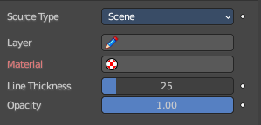
Scene
Applies the line art grease pencil strokes to the whole scene.

Layer
Grease Pencil layer that is assigned to the generated strokes.

Material
Grease pencil material assigned to the generated strokes.

Line Thickness
The thickness of the line.

Opacity
The opacity of the line.

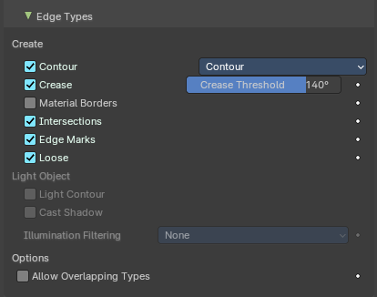
Edge types subpanel
Which kind of edges to influence.

Create

Use Contour
Use a contour.

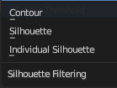
Silhouette Filtering
What kind of contour to use.

Use Crease
Generate strokes from crease edges.

Crease Threshold
Angles smaller than this value will be treaten as creases.

Crease
Influence crease edges. The angle what edges are treaten as creases can be adjusted in the edit box.

Material Borders
Generate strokes from borders between materials.

Intersections
Generate strokes from intersections.

Edge Marks
Generate strokes from edge marks.

Loose
Generate strokes from loose geometry.

Light Object

Light Contour
You need to pick a light object in the Light Reference panel. Generate light shadow separation lines from a referenced light object.

Cast Shadow
You need to pick a light object in the Light Reference panel. The line casts shadow.

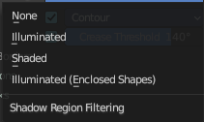
Illumination filtering
You need to pick a light object in the Light Reference panel. How to thread the shadow region filtering. The names should be self explaining.

Options

Allow Overlaping Types
Allow an edge to have multiple overlapping types.

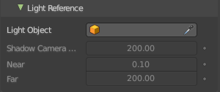
Light Reference subpanel
This panel allows you to add a light object as a source for line art.

Light Object
Pick the light source.

Shadow Camera Size
Represents the orthographic scale of an ortho camera. It calculates the area to cover.

Near
The near clip plane of the shadow camera.

Far
The far clip plane of the shadow camera.

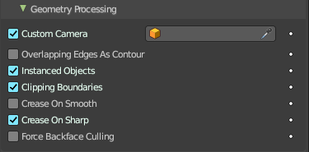
Geometry Processing subpanel

Custom Camera
Allows to pick a different camera than the active scene camera for line art rendering.

Overlapping Edges as Contour
This option allows overlapping edges (e.g. from an edge split modifier or imported geometry where two edges occupy the exact same space) to be drawn as contour. Enabling this option will slow down the calculation slightly but it will handle edge overlapping cases without erroneous occlusion results.

Instanced Objects
This option enables particles and other instanced objects to be loaded for line art calculation. There will be performance impact when there are a large amount of instanced objects in the scene.

Clipping Boundaries
When enabled, line art will generate clipping lines as contour type at the place where near or far clipping planes cut the model. Otherwise there will be no lines.

Crease on Smooth
Allow crease edges to show inside smooth surfaces.

Crease on Sharp
Allow crease to show on sharp edges.

Force Back Face Culling
Remove all backfaces to speed up calculation.

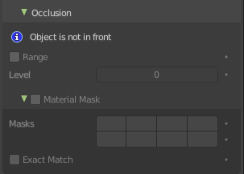
Occlusion Subpanel

Range
If enabled, the modifier will select lines that have an occlusion level between start and end values.
If not enabled just a single Level value slider shows.

Material Mask subpanel
Use material masks to filter out occluded strokes. You need to have a range level higher than 0.

Masks
Choose up to eight mask bits for the masking.

Exact match
Require matching all material masks instead of just one.

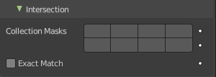
Intersection subpanel

Collection Masks
Choose up to eight mask bits for masking.

Exact match
Require matching all intersections instead of just one.

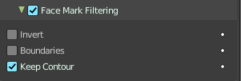
Face Mask Filtering subpanel
Filter Feature Lines using Freestlye Face Masks.

Invert
Invert face mask filtering.

Boundaries
Filter feature lines based on face mask boundaries.

Keep Contour
Preserve contour lines while filtering.

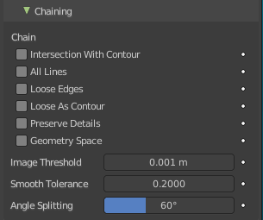
Chain

Intersection with Contour
Allows intersection lines to be chained together with contour lines.

All Lines
Enabling this option will cause all lines to have the type of contour and to be chained together.

Loose Edges
Allow loose edges to be chained together.

Loose As Contour
Loose edges will have contour type.

Preserve Details
Keep the zig-zag noise in initial chanining.

Geometry Space
Use Geometry distance for chaining instead of image space.

Image Threshold
Segments with an image distance smaller than this value will be chained together.

Smooth tolerance
Strength of smoothing applied on jagged chains.

Angle Splitting
The angle in screen space below which a stroke is split into two.

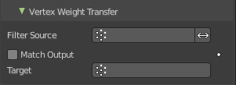
Vertex Weight Transfer subpanel

Filter Source
If source mesh has vertex groups whose name starts with this string, then the vertex weight info will be transferred into weight groups in Grease Pencil strokes.

Invert Vertex Group
Inverts the selection.

Match Output
Transfer the filtered object vertex weights into Grease Pencil weight groups with the same names as the filtered ones.

Target
If Match Output is off, then a target vertex group has to be specified. If there are multiple weight groups copied into target, then the highest weight value is copied into it.

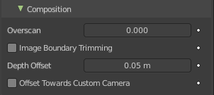
Composition

Overscan
A margin to prevent an abrupt end of the stroke at the edge of the image.

Image boundary trimming
Trim all edges right at the boundary of image (including overscan region)

Depth Offset
Move strokes slightly towards the camera to avoid clipping.

Towards custom camera
Offset strokes towards selected camera instead of the active camera.

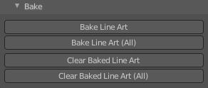
Bake subpanel

Bake Line Art / Bake Line Art (All)
Bakes Line Art strokes for active Grease Pencil object within the start, end frame range in scene.
Bake Line Art (All) bakes all Grease Pencil objects that contains at least one Line Art modifier. After baking, baked Line Art modifier will be deactivated automatically.

Clear Baked Line Art / Clear Baked Line Art ( All)
Clears baked line art frames within the scene frame range for active Grease Pencil object.
Clear Baked Line Art (All) applies the same operation for all Grease Pencil objects that contains at least one Line Art modifier.

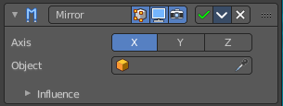
Mirror
The Mirror modifier for the Grease Pencil Object works in Object mode. It mirrors the object along its local X, Y and/or Z axes, across the Object Origin. It can also use another object as the mirror center, then use that object’s local axes instead of its own.

Object
Define an object to mirror at its origin instead of mirroring along the grease pencil origin.
You can animate it to move the mirror axis.

Influence

Layer
Restricts the effect only to one layer or to any layers that share the same pass index. Click to pick the layer that you want to use.

Invert
Inverts the influence.

Layer Pass
The layer pass index.

Use Layer pass
Use the layer pass.

Layer pass value
The layer pass value.

Invert
Inverts the influence.

Material
Restricts the effect only to material that share the same material or pass index. Click to pick the material that you want to use.

Invert
Inverts the influence.

Material Pass
The material pass index.

Use Material pass
Use the Material pass.

Material pass value
The Material pass value.

Invert
Inverts the influence.

Multiple Strokes
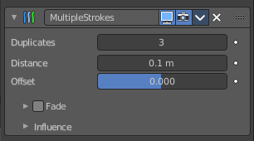
Adds multiple parallel copies of the stroke around the original stroke.

Duplicates
The number of additional strokes.

Distance
Distance between the original and the duplicate strokes.

Offset
Control the offset position (inner or outer) for duplicate strokes.

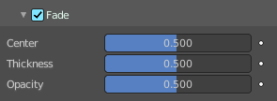
Fade
Fade out duplicate strokes, using their opacity or thickness.

Center
Control the initial position for the fading.

Thickness
Fade influence on strokes thickness.

Opacity
Fade influence on strokes opacity.

Influence subpanel

Layer
Restricts the effect only to one layer or to any layers that share the same pass index. Click to pick the layer that you want to use.

Invert
Inverts the influence.

Layer Pass
The layer pass index.

Use Layer pass
Use the layer pass.

Layer pass value
The layer pass value.

Invert
Inverts the influence.

Material
Restricts the effect only to material that share the same material or pass index. Click to pick the material that you want to use.

Invert
Inverts the influence.

Material Pass
The material pass index.

Use Material pass
Use the Material pass.

Material pass value
The Material pass value.

Invert
Inverts the influence.

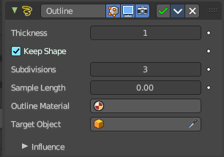
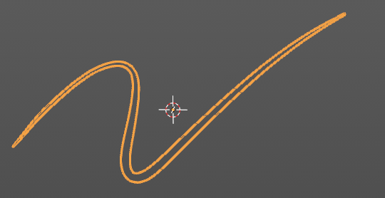
Outline
Draws an outline around the grease pencil stroke.

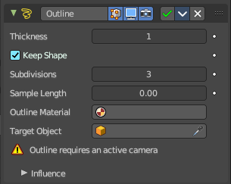
This modifier requires to have a ACTIVE camera in the scene, since the outline is created from this active camera. And the outline is created from exact this view of the camera. So better switch to camera view to check if the view fits. You will get a warning in the modifier when the active camera is missing.

The active camera has the active orange triangle above the widget. You can also see the active camera in the Scene properties.

Thickness
The thickness of the outline.

Keep Shape
Try to keep global shape.

Subdivisions
Subdivisions of the outline grease pencil stroke.

Sample Length
The distance between the vertices.

Outline material
Material used for the outline strokes. If no material is chosen then the material from the parent stroke is used.

Target object
A target object to define the stroke start.

Influence subpanel

Layer
Restricts the effect only to one layer or to any layers that share the same pass index. Click to pick the layer that you want to use.

Invert
Inverts the influence.

Layer Pass
The layer pass index.

Use Layer pass
Use the layer pass.

Layer pass value
The layer pass value.

Invert
Inverts the influence.

Material
Restricts the effect only to material that share the same material or pass index. Click to pick the material that you want to use.

Invert
Inverts the influence.

Material Pass
The material pass index.

Use Material pass
Use the Material pass.

Material pass value
The Material pass value.

Invert
Inverts the influence.

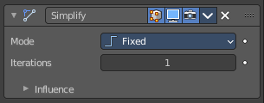
Simplify
The Simplify modifier allows you to reduce the amount of points in the strokes. It tries to reduce points while maintaining the lines shape.

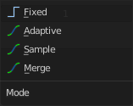
Mode
How to reduce points in the strokes.

Fixed
Deletes alternated points in the strokes, except the start and end points.

Adaptive
Uses the RDP algorithm (Ramer-Douglas-Peucker algorithm) for points deletion. The algorithm try to obtain a similar line shape with fewer points.

Sample
Recreates the stroke geometry with a predefined length between points.

Merge
Simplifies the strokes by merging points that are closer than a specified distance to each other.

Iterations
Number of times to repeat the procedure.

Influence subpanel

Layer
Restricts the effect only to one layer or to any layers that share the same pass index. Click to pick the layer that you want to use.

Invert
Inverts the influence.

Layer Pass
The layer pass index.

Use Layer pass
Use the layer pass.

Layer pass value
The layer pass value.

Invert
Inverts the influence.

Material
Restricts the effect only to material that share the same material or pass index. Click to pick the material that you want to use.

Invert
Inverts the influence.

Material Pass
The material pass index.

Use Material pass
Use the Material pass.

Material pass value
The Material pass value.

Invert
Inverts the influence.

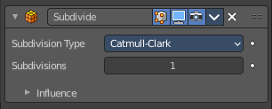
Subdivide
The Subdivide modifier subdivide the strokes by inserting points between other points to the lines.

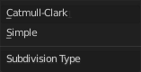
Subdivision Type

Catmull-Clark
Subdivides and smooths the surfaces.

Simple
Only subdivides the surfaces, without any smoothing.

Subdivisions
Number of subdivisions.

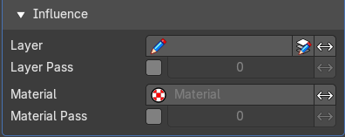
Influence subpanel

Layer
Restricts the effect only to one layer or to any layers that share the same pass index. Click to pick the layer that you want to use.

Invert
Inverts the influence.

Layer Pass
The layer pass index.

Use Layer pass
Use the layer pass.

Layer pass value
The layer pass value.

Invert
Inverts the influence.

Material Pass
Restricts the effect only to material that share the same material or pass index. Click to pick the material that you want to use.

Use Material pass
Use the Material pass.

Material pass value
The Material pass value.

Invert
Inverts the influence.

Pass
The material pass index.

Invert
Inverts the influence.

